1. Install JDK 11 or higher ([Java Archive Downloads - Java SE 11 | Oracle India](https://www.oracle.com/in/java/technologies/javase/jdk11-archive-downloads.html))

2. Download and Install STS ( [Spring | Tools](https://spring.io/tools) )

3. Install Redis

Navigate to GitHub repository : [Releases · tporadowski/redis](https://github.com/tporadowski/redis/releases)

Download latest Version and Extract it

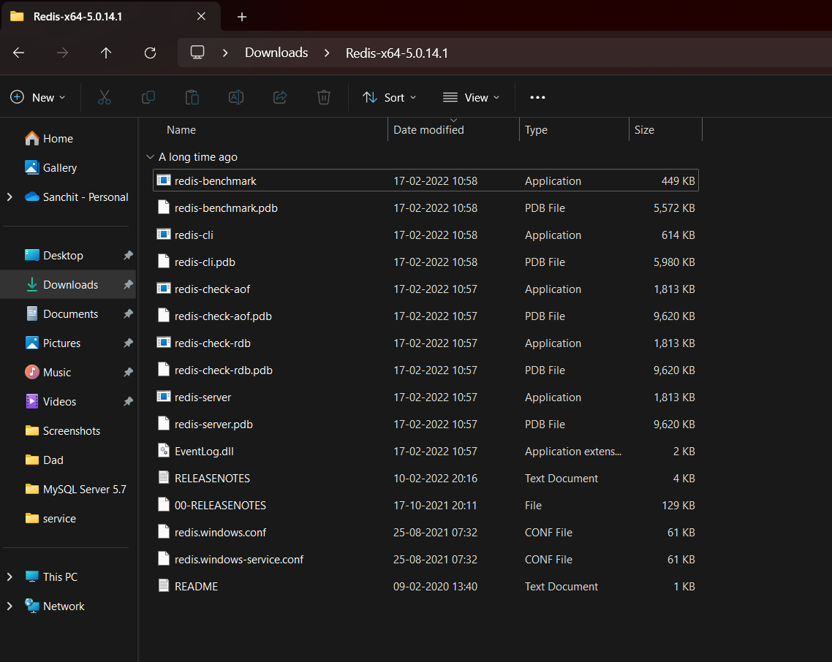

Open CMD in this location and give command : redis-server

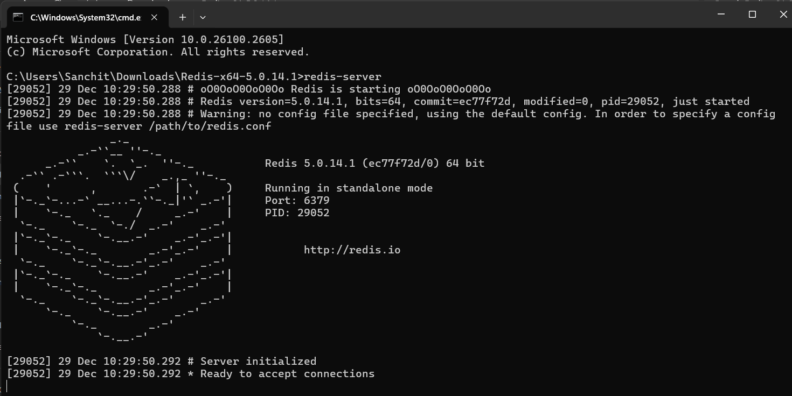

Redis is now up and running on port 6379

Open CMD in this location and give command : redis-cli

Give command : ping -> if redis server is up and running it should return message “PONG”

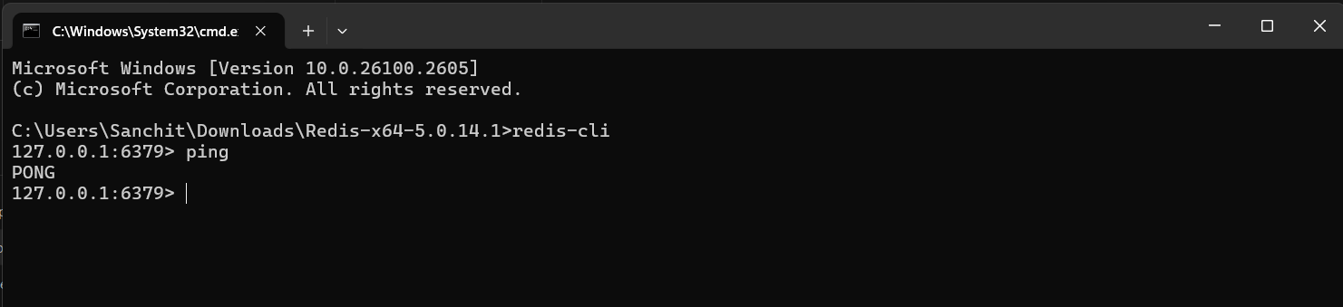

4. MySQL SSL setup

Download and Install MySQL database ([MySQL Enterprise Edition Downloads | Oracle](https://www.oracle.com/mysql/technologies/mysql-enterprise-edition-downloads.html#windows))

On MySQL Workbench > Create New Connection

Give username and password, hostname, port

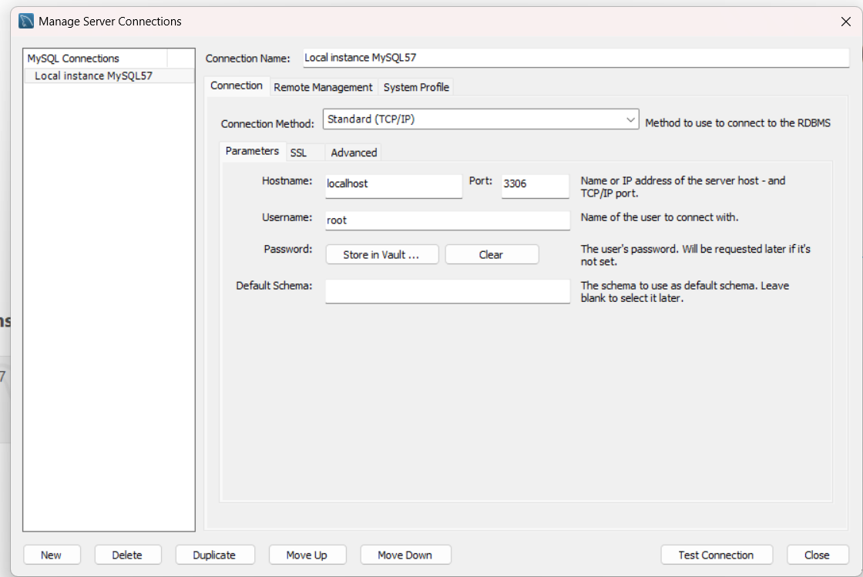

Navigate to SSL tab > SSL Wizard

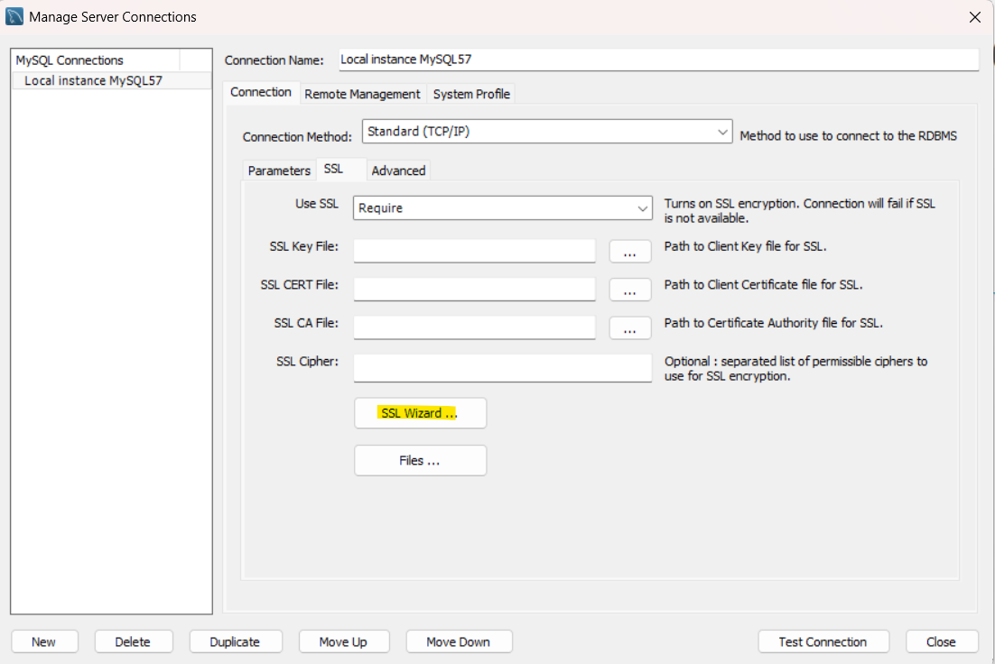

Create new Certificates

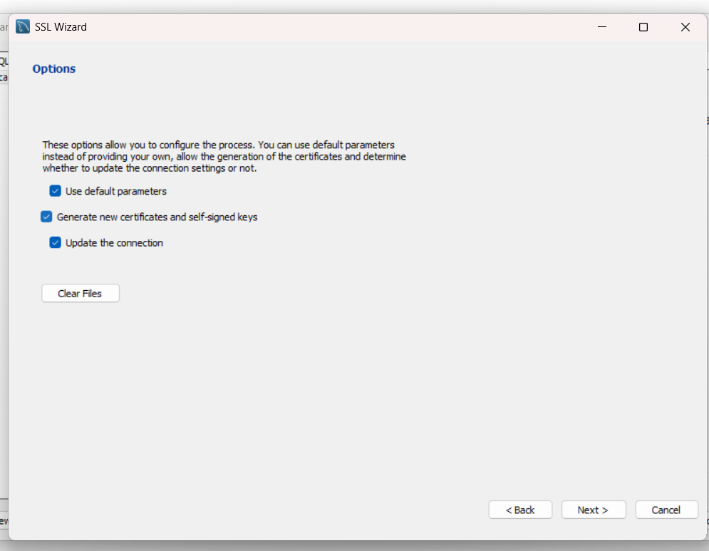

New SSL Certificates created:

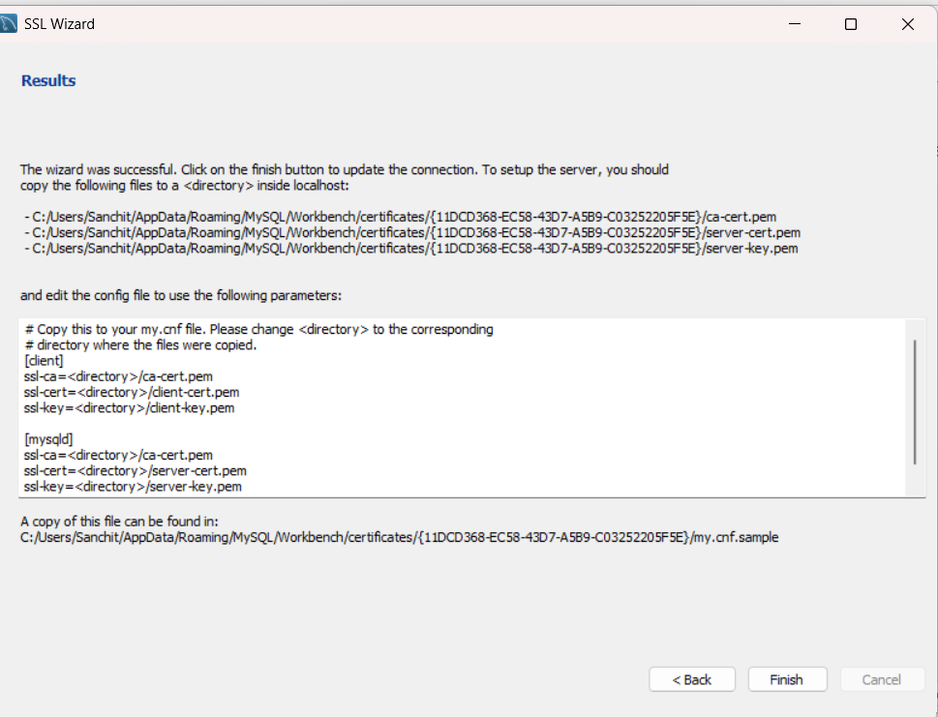

Make sure in your my.inf file these directory for client, Server key and certificate are updated

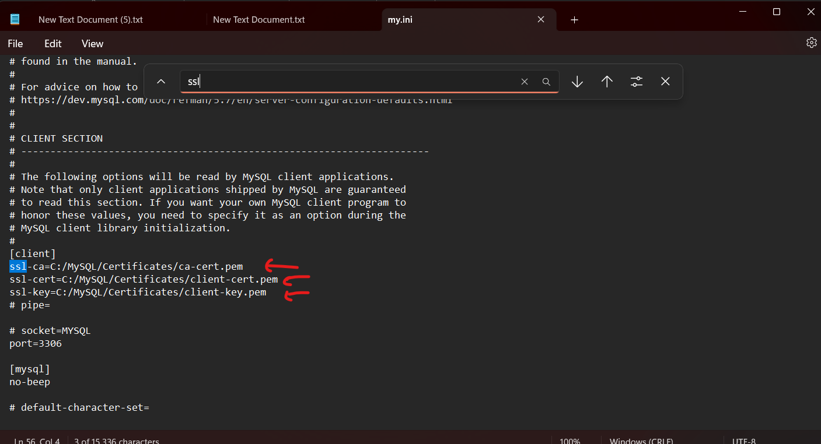

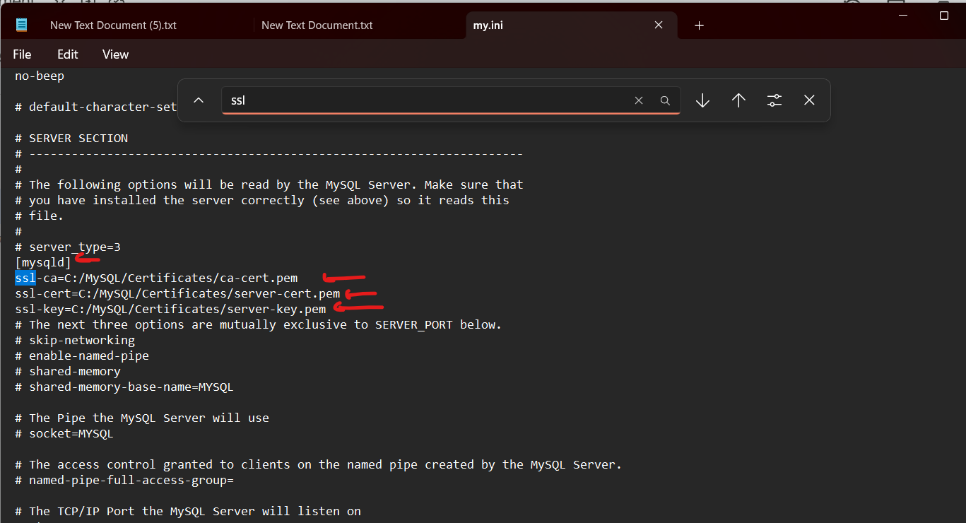

5. Open STS and configure Project from application.properties

